COMPERHENSIVE PROJECT REPORT

Project Name: Flow to Grow: Boosting School Confidence for Girls
Location: Addis Ketema Sub City, Addis Ababa
Duration: 18 Months

Implemented by: Dr. Ambachew Mekonnen Foundation (AMF)

Supported by: USAID Read II Project & Private Donors

July 15, 2025 G.C

Executive Summary
The “Flow to Grow: Boosting School Confidence for Girls” project was implemented by the Dr. Ambachew Mekonnen Foundation (AMF) to address menstrual health and hygiene challenges affecting female students in Addis Ketema Sub-City, Addis Ababa. The project aimed to improve girls’ confidence, educational participation, school attendance, and overall well-being through menstrual hygiene support, awareness creation, gender-based violence (GBV) prevention training, and community engagement.
The intervention was initially launched as a six-month pilot project in 5 public schools but later expanded to 15 schools across 7 woredas in Addis Ketema Sub-City due to its visible impact, increasing community demand, and growing stakeholder engagement. The implementation period was subsequently extended to 18 months (one and a half years), allowing the project to scale both geographically and institutionally.
Implemented by AMF with support from an individual donor and the USAID READ II Project, the initiative combined direct menstrual hygiene support with awareness creation, school engagement, and community mobilization. Through strategic collaboration with schools, Parent-Teacher Associations (PTAs), gender clubs, teachers, parents, and students, the project reached more than 900 students with awareness training on menstrual health management, gender equality, and GBV prevention, while 750 vulnerable female students directly benefited from sanitary pads, soap, scholastic materials, and trainings.
One of the project’s major achievements was improving school attendance and participation among girls by reducing menstruation-related absenteeism through the provision of sanitary pads and hygiene support materials. Teachers and school leaders observed noticeable improvements in girls’ classroom participation, confidence, interaction with peers, and willingness to engage in school activities.
The project demonstrated that relatively small but targeted interventions can significantly improve girls’ dignity, confidence, educational continuity, and psychosocial well-being while reducing stigma associated with menstruation. The intervention also strengthened community and school-level commitment to supporting girls’ education and well-being through active engagement of teachers, PTAs, gender clubs, and school leadership.
Findings from both baseline and endline assessments confirmed that menstrual health challenges continue to negatively affect girls’ educational participation, attendance, confidence, and psychosocial well-being. However, the project contributed to improved awareness, stronger institutional commitment from schools, increased openness in discussing menstrual health issues, and strengthened support systems for adolescent girls.
The project further served as a significant institutional milestone for AMF, demonstrating the organization’s capacity to design, implement, coordinate, and scale community-centered interventions focused on women and girls’ empowerment.

Contents
1. Organizational Background 4
2. Project Background 4
3. Project Goal and Objectives 5
Overall Goal 5
Specific Objectives 5
4. Baseline Assessment Findings 5
5. Project Implementation 6
5.1 Expansion and Reach 6
5.2 Menstrual Health and Hygiene Support 10
5.3 Awareness Creation and Capacity Building 12
5.4 Community and Stakeholder Engagement 13
5.4 Project Closure Workshop 16
5.5 Educational Book Donation During the Project Closure Workshop 18
6. Endline Assessment Findings 20
6.1 School Principals’ Perspectives 20
6.2 School Girls’ Perspectives 21
Annexes 23

Organizational Background
The Dr. Ambachew Mekonnen Foundation (AMF) was established in 2020 to continue the vision of the late Dr. Ambachew Mekonnen through promoting social justice, inclusive development, education, and community empowerment in Ethiopia. Since its establishment, AMF has focused on supporting vulnerable populations, particularly women, girls, and youth, through education, empowerment, and livelihood initiatives.
One of AMF’s earliest initiatives focused on recognizing academic excellence among secondary school students through the Dr. Ambachew Memorial School Program. Between 2020 and 2022, the Foundation awarded 36 outstanding students in Mathematics, Physics, and Economics from grades 9 to 12. Sequential award recipients who successfully joined universities were also supported with laptops to strengthen their academic journey.
Building on this educational engagement, AMF launched its first structured project intervention in 2024 under the title “Flow to Grow: Boosting School Confidence for Girls.”

Project Background
The Flow to Grow (FTG) Project was initiated in response to growing concerns regarding the impact of menstrual health and hygiene challenges on girls’ educational participation, confidence, and psychosocial well-being within school environments. In many schools, female students continue to experience absenteeism, reduced classroom participation, stigma, and emotional distress associated with menstruation due to limited access to sanitary materials and inadequate support systems. The project aimed to improve girls’ educational experience and self-confidence through menstrual hygiene support, awareness creation, and school-community engagement while promoting safe, inclusive, and gender-responsive learning environments.
The intervention was implemented by the Dr. Ambachew Mekonnen Foundation (AMF) with support from an individual donor and the USAID READ II Project.
Initially designed as a six-month pilot intervention targeting five schools in Addis Ketema Sub-City, the project later expanded into an 18-month intervention covering 15 public schools across 7 woredas due to strong community demand, positive school-level feedback, and visible improvements observed among participating students.
The intervention initially targeted the following schools:
- Dagmawi Birhan School
- Eshet Primary School
- Feleg Birhan School
- Shawel Dema School
- Dejazmach Geneme School
Following the expansion phase, additional schools joined the initiative, including Betweded School, Birhan Ena Selam School, Ewket Amba School, Hamle School, Mayday School, Tsehaygibat School, Birhan Ber School, Gelila School, and Sefere Selam School.
The project was designed not only to address immediate menstrual hygiene needs, but also to strengthen long-term institutional and community support systems for girls’ education, dignity, protection, and well-being.

Project Goal and Objectives

Overall Goal
To improve girls’ confidence, educational participation, and well-being through comprehensive menstrual health and hygiene interventions and gender-responsive school engagement.

Specific Objectives
- Improve menstrual health awareness among students and school communities.
- Reduce stigma and misconceptions related to menstruation.
- Improve girls’ school attendance and participation.
- Strengthen confidence and self-esteem among female students.
- Promote gender equality and GBV prevention awareness.
- Strengthen school-community engagement in supporting girls’ education and protection.

Baseline Assessment Findings
Before implementation, AMF conducted a survey among school principals to understand the existing challenges affecting female students in relation to menstrual health and hygiene management.
The findings demonstrated that menstrual health challenges were significantly affecting girls’ educational participation.
- 60% of respondents reported that female students struggled with low self-esteem and lack of confidence during menstruation.
- 30% indicated that girls frequently missed school during menstruation.
- 10% reported cases of school dropout linked to menstrual health challenges.
- 100% of respondents agreed that menstrual health issues negatively affected girls’ school attendance and participation.
- 80% believed that absenteeism and dropout were directly related to poor menstrual hygiene management.
The assessment also revealed limited prior support mechanisms in schools:
- Only 20% of schools had previously provided menstrual hygiene products.
- 40% reported conducting menstrual health-related training.
- 40% indicated efforts to create discussion-friendly environments for girls.
Financial constraints were identified as the major barrier affecting implementation of menstrual health support activities.
The baseline assessment highlighted the urgent need for coordinated interventions combining awareness creation, menstrual hygiene support, and institutional strengthening within schools.

Project Implementation

5.1 Expansion and Reach
The Flow to Grow project initially started as a small pilot intervention targeting 100 vulnerable female students in five schools located in Addis Ketema Sub-City. However, due to the strong relevance of the intervention and the visible improvements observed within schools, the project gradually expanded both in geographic coverage and institutional engagement.
As implementation progressed, additional schools expressed interest in participating in the initiative after observing positive changes among supported students, particularly improvements in girls’ confidence, attendance, participation, and openness to discussing menstrual health issues. This organic expansion demonstrated the practical need for menstrual health support within school environments and reflected the growing trust schools placed in AMF’s community-based approach.
By the end of implementation, the project had expanded from the original five schools to 15 participating schools. These included Dagmawi Birhan School, Eshet School, Felege Birhan School, Shawel Dema School, Dejazmach Geneme School, Betweded School, Birhan Ena Selam School, Ewket Amba School, Hamle School, Mayday School, Tsehaygibat School, Birhan Ber School, Gelila School, and Sefere Selam School.
The expansion significantly increased the project’s outreach and impact among students, teachers, and school communities. Through the scaled-up intervention:
- 750 female students directly benefited from sanitary pads, soap, scholastic materials, and hygiene support.
- More than 900 students (approximately 550 girls and 350 boys) received awareness training on menstrual health management, gender equality, and gender-based violence prevention.
- School principals, teachers, PTAs, and gender club leaders became actively engaged in promoting girls’ participation and protection.
The project’s implementation strategy emphasized both direct support and long-term behavioral change. Rather than focusing only on distribution of sanitary materials, the intervention combined menstrual hygiene management, psychosocial awareness, school engagement, and gender equality promotion.
Several implementation approaches contributed to the project’s success:

Integrated School-Based Support
The project adopted a school-centered implementation approach where support activities were coordinated directly with school leadership and gender clubs. This strengthened institutional ownership and enabled schools to actively participate in identifying vulnerable students, facilitating training sessions, and monitoring the well-being of girls.
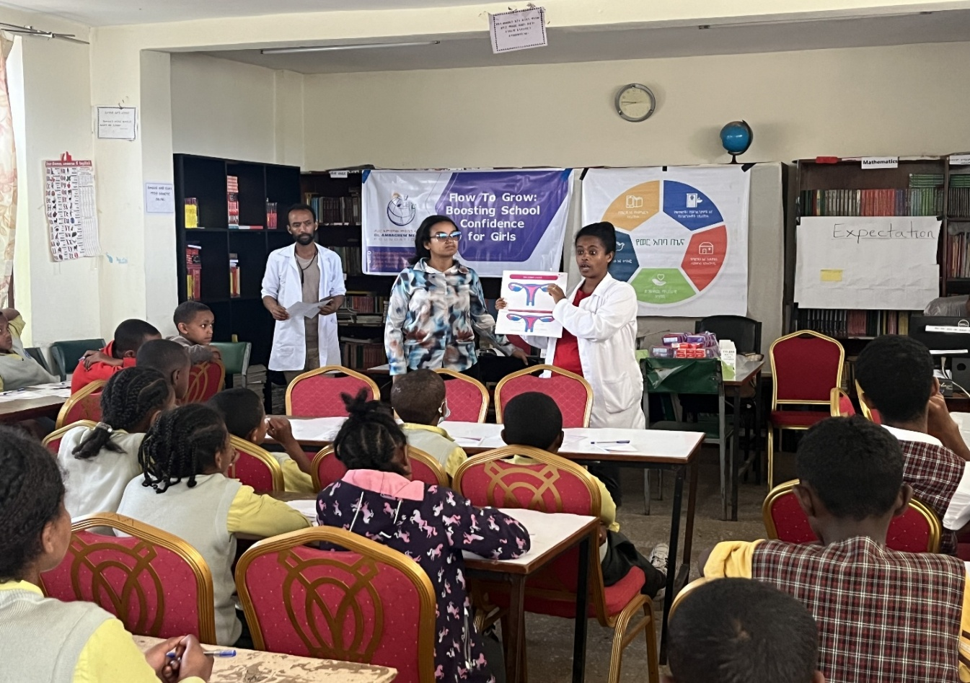

Targeted Material Support
Female students received sanitary pads, soap, and scholastic materials to reduce practical barriers affecting attendance and participation during menstruation. In several schools, teachers reported that students who had previously missed classes due to lack of menstrual hygiene materials were able to attend school more consistently after receiving support.
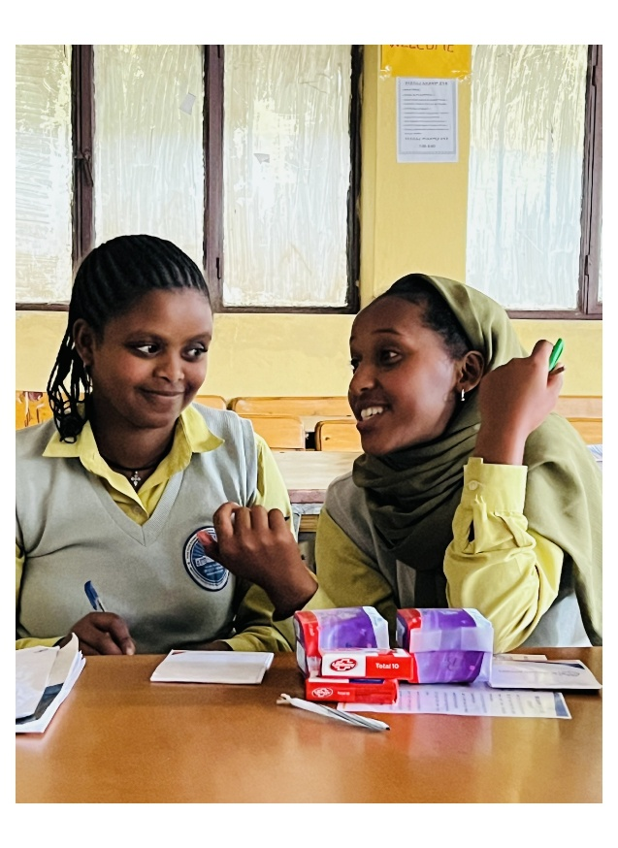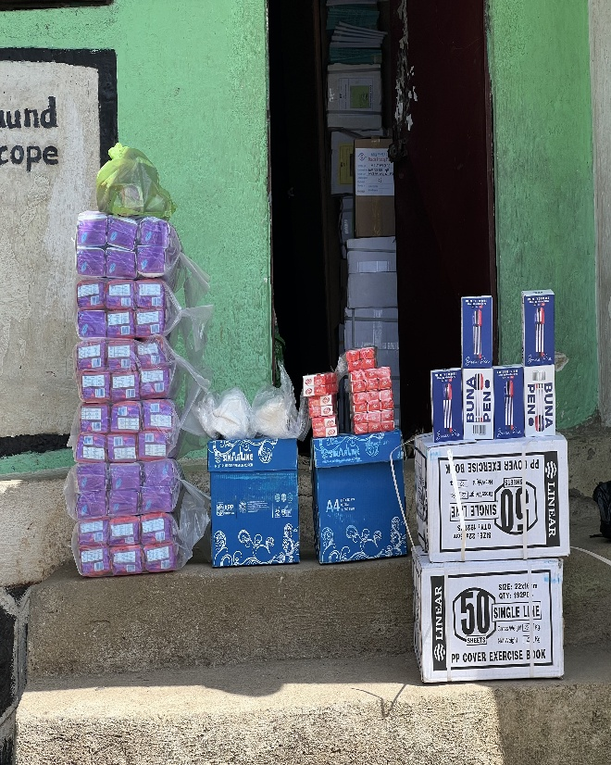
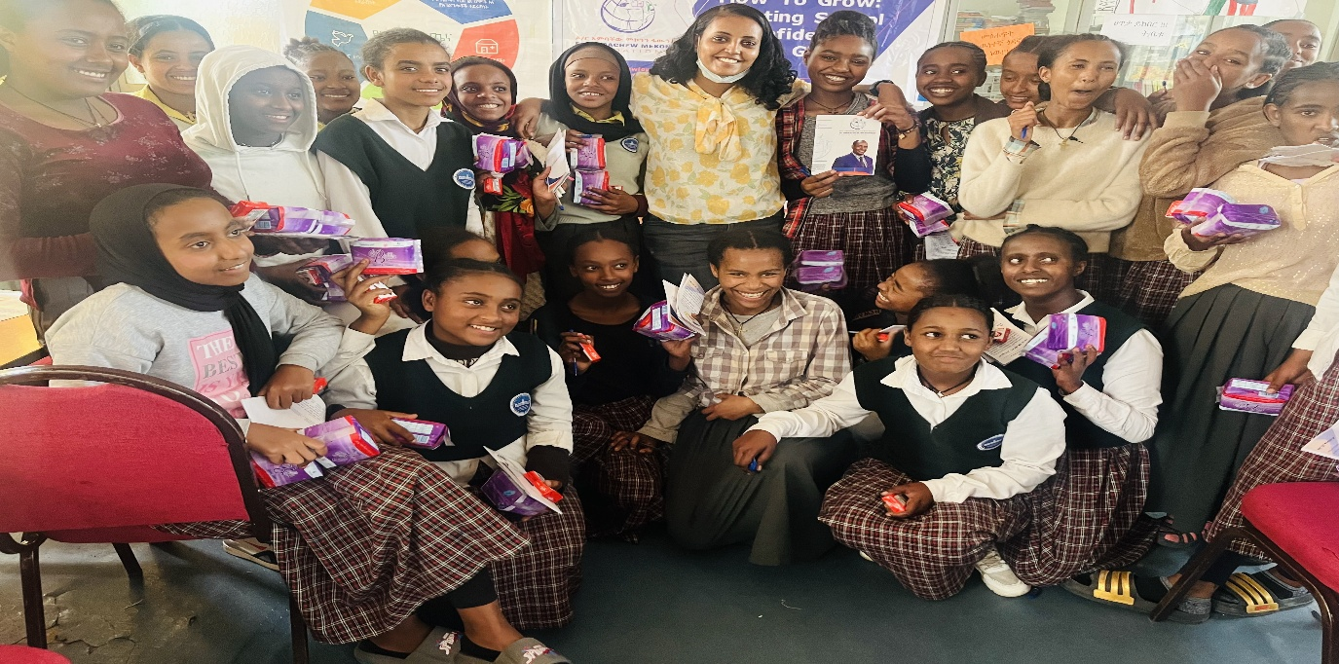

Male Student Engagement
d
One of the project’s strongest achievements was the inclusion of boys in menstrual health and GBV awareness sessions. Traditionally, menstrual health discussions are often limited to girls, which can contribute to stigma, teasing, and misinformation among male students. By involving boys directly in awareness sessions, the project encouraged empathy, understanding, and shared responsibility in promoting respectful school environments.  Teachers and school leaders reported that male students became more supportive and respectful toward female classmates, while girls increasingly felt more comfortable participating openly in school activities. | 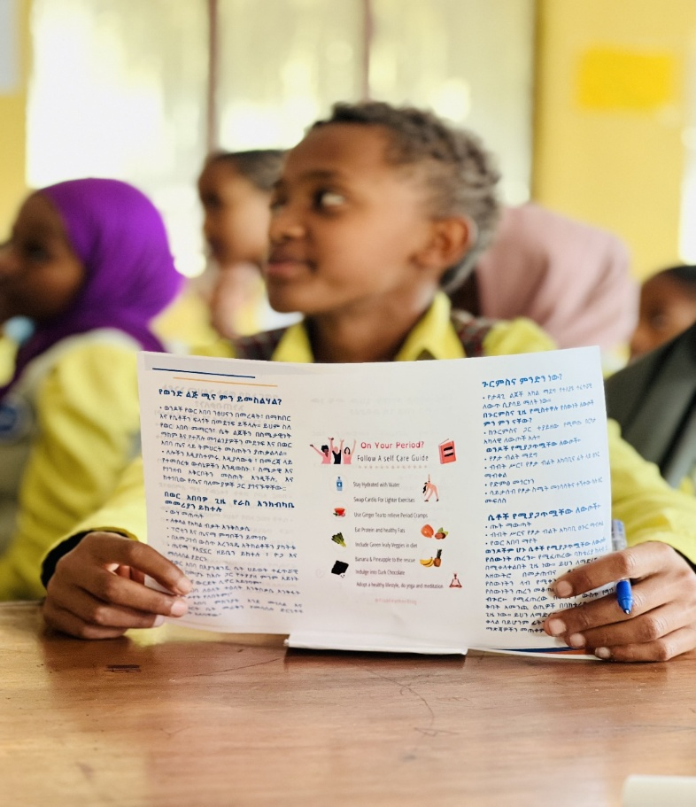

Strengthening Gender Clubs and School Structures
The project also strengthened existing gender clubs and school-level support mechanisms. Gender clubs became more active in organizing awareness sessions and allowing member students to sustain the good practices already started through the project initiative.
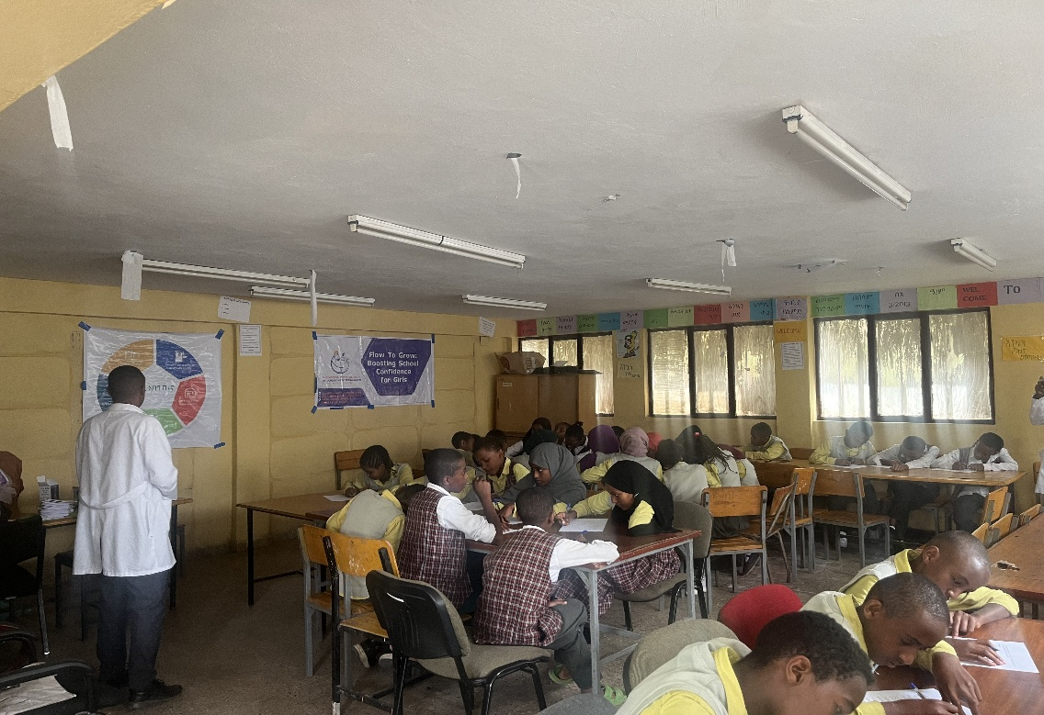

5.2 Menstrual Health and Hygiene Support
At the core of the Flow to Grow project was the recognition that menstrual health and hygiene management is directly linked to girls’ dignity, educational continuity, self-confidence, and psychosocial well-being. Prior to the intervention, many female students in participating schools faced significant challenges in managing menstruation safely and confidently. Limited access to sanitary materials, fear of embarrassment, and lack of supportive environments frequently contributed to absenteeism, reduced classroom participation, and emotional distress among adolescent girls.
To address these barriers, the project provided direct menstrual hygiene support through the distribution of sanitary pads, soap, and other hygiene-related materials to vulnerable female students. The intervention also integrated scholastic support materials such as notebooks, pens, printer paper, and sports materials to strengthen overall educational participation and create a more supportive and motivating learning environment.
The support provided under the project went beyond meeting immediate material needs. For many students, receiving menstrual hygiene support represented recognition, dignity, and reassurance that their educational participation mattered. Teachers and school leaders consistently reported visible changes among supported students following the intervention. Girls who had previously missed classes during menstruation became more regular in school attendance, while others demonstrated increased confidence in participating in classroom discussions and extracurricular activities.
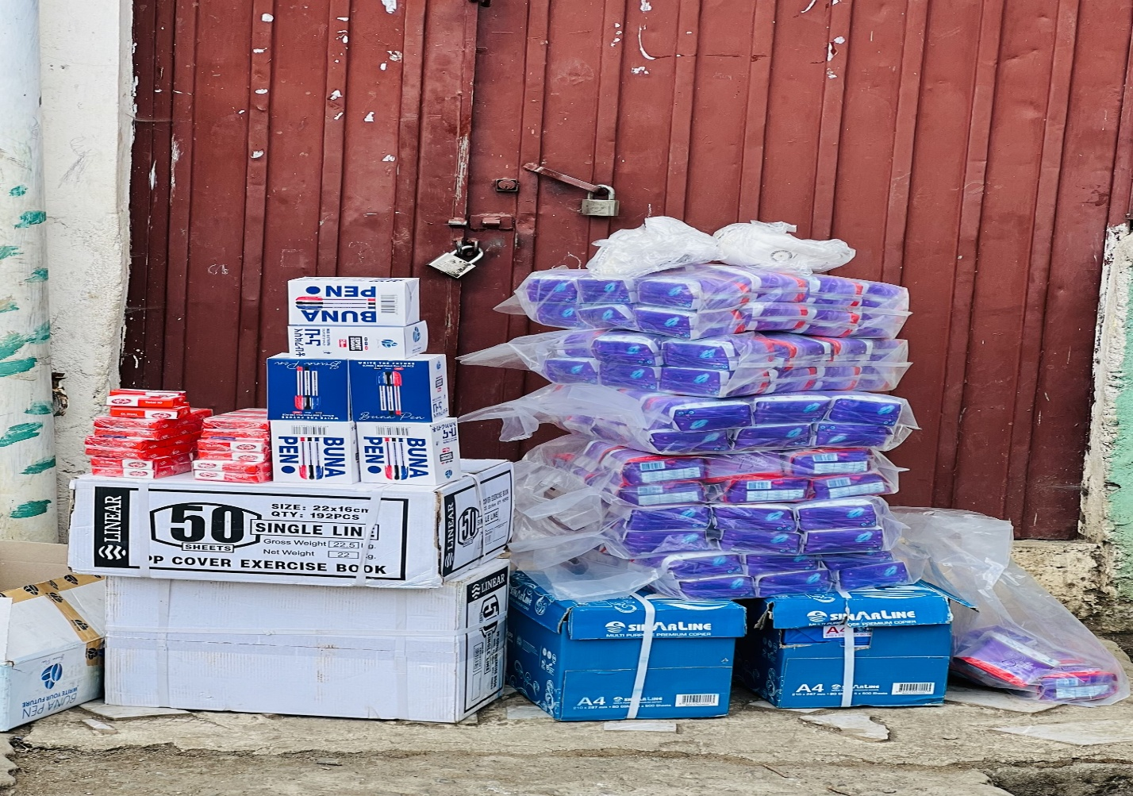
Several schools further observed improvements in communication and interaction between students and teachers. Female students increasingly became more open to discussing menstrual health challenges and seeking support when needed. In some schools, teachers reported that girls who had previously isolated themselves during menstruation began engaging more actively with peers and participating in group activities.
The provision of scholastic and recreational materials also contributed to strengthening girls’ motivation and school attachment. School communities highlighted that combining menstrual hygiene support with educational materials created a more holistic intervention that addressed both practical and psychosocial barriers affecting girls’ learning experiences.
Importantly, the intervention demonstrated that relatively simple and low-cost support mechanisms can produce significant educational and social outcomes when implemented consistently and in coordination with schools and communities. The project highlighted that menstrual hygiene management should not be viewed solely as a health issue, but also as a matter of educational access, protection, gender equality, and student dignity.

5.3 Awareness Creation and Capacity Building
Beyond material support, the Flow to Grow project placed strong emphasis on awareness creation and capacity building as essential components for achieving sustainable change. The project recognized that lack of awareness, misinformation, harmful stigma, and silence surrounding menstruation remained major barriers affecting girls’ educational participation and psychosocial well-being.
To address these challenges, the project implemented a series of awareness creation and training activities targeting students, teachers, school leaders, gender clubs, parents, and wider school communities. The trainings focused on improving understanding of menstrual health and hygiene management, promoting gender equality, and strengthening awareness regarding gender-based violence prevention and response mechanisms.
The awareness sessions created important opportunities for open dialogue within school environments where discussions around menstruation had previously been limited or culturally sensitive. Through participatory discussions, practical demonstrations, and interactive learning approaches, students were encouraged to ask questions, share experiences, and challenge misconceptions surrounding menstrual health.
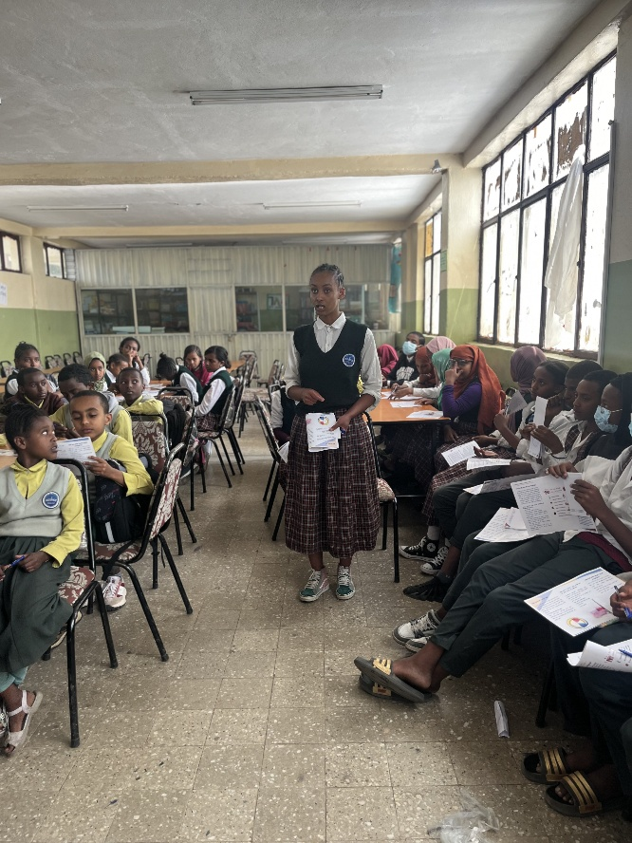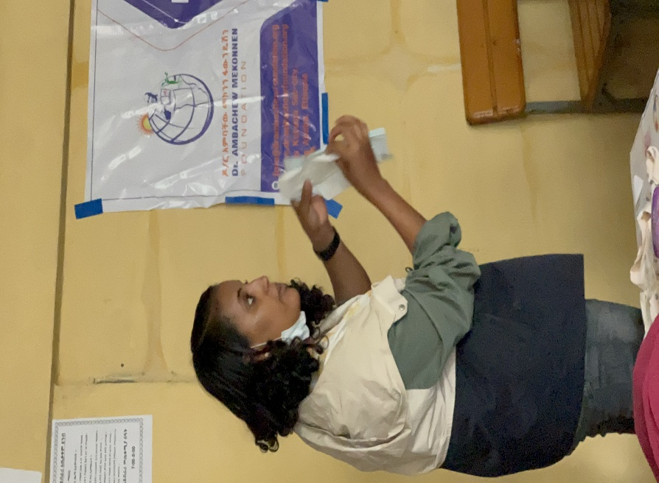
A major focus of the training activities was reducing shame and stigma associated with menstruation. Many participants acknowledged that menstruation had traditionally been treated as a taboo subject, leading girls to experience embarrassment, fear, and social isolation. The project therefore worked to normalize discussions around menstrual health and encourage more supportive attitudes among students and teachers alike.
Teachers and school leaders also received awareness support aimed at strengthening their capacity to respond sensitively to girls’ needs. This contributed to improved understanding among educators regarding the relationship between menstrual health, psychosocial well-being, and educational participation.
One of the project’s most impactful strategies was the active inclusion of male students in awareness sessions. Rather than limiting menstrual health discussions to girls only, the project intentionally engaged boys in conversations around respect, gender equality, dignity, and violence prevention. This approach helped reduce teasing and discriminatory behavior while promoting empathy and shared responsibility among male students.
The awareness and capacity-building activities further strengthened institutional recognition of menstrual hygiene management as both an educational and protection issue. Schools increasingly acknowledged that supporting girls during menstruation was essential for ensuring equal participation, reducing absenteeism, and promoting safe and inclusive learning environments.
Overall, the awareness creation component contributed to improved openness, stronger peer support, increased confidence among girls, and greater willingness among schools and communities to continue discussing menstrual health issues beyond the project period.

Community and Stakeholder Engagement
The Flow to Grow project recognized that sustainable improvements in menstrual health and girls’ educational participation require broad community involvement and collective responsibility. As a result, the project actively engaged a wide range of stakeholders throughout implementation, including school principals, teachers, gender clubs, parent-teacher associations (PTAs), students, parents, and local community representatives.
This inclusive engagement approach helped strengthen local ownership of the intervention while encouraging schools and communities to view menstrual health and gender equality as shared social and educational concerns rather than private individual matters.
One of the project’s most significant stakeholder engagement initiatives was the 16 days of activism organized around fighting Gender-Based violence with a motto “Stop Violence! Empower Her Future”. AMF organized a workshop at Tulip Olymplia Hotel in Addis Ababa on December 9, 2024 G.C as part of 16 Days of Activism campaign. The workshop served as a platform for dialogue, awareness creation, and collective reflection on issues affecting girls’ dignity, safety, and educational participation.
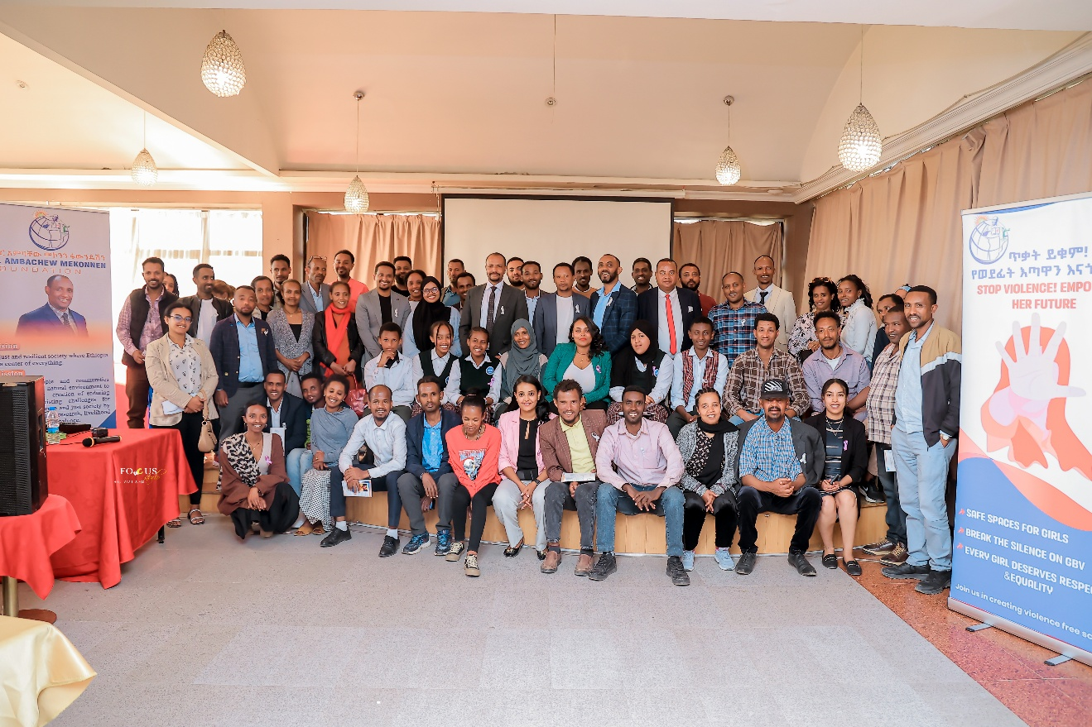
The event brought together students, teachers, parents, school leaders, community stakeholders, and government representatives to discuss gender-based violence prevention, reporting mechanisms, and the importance of creating safe and supportive environments for girls both within schools and in the wider community.
The workshop encouraged participants to openly discuss challenges related to GBV, menstrual stigma, and girls’ protection. Through facilitated discussions, participants shared experiences, concerns, and recommendations for improving support systems for adolescent girls.

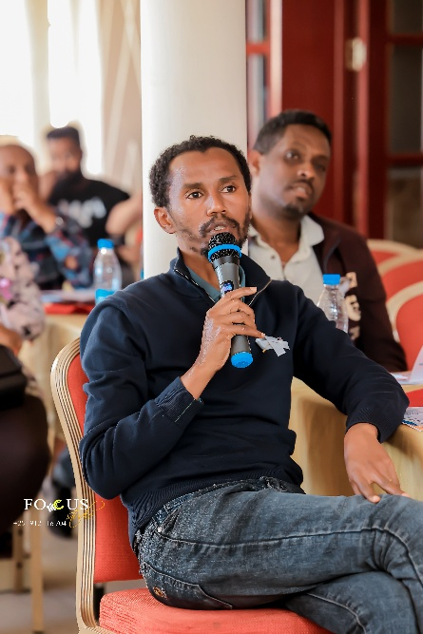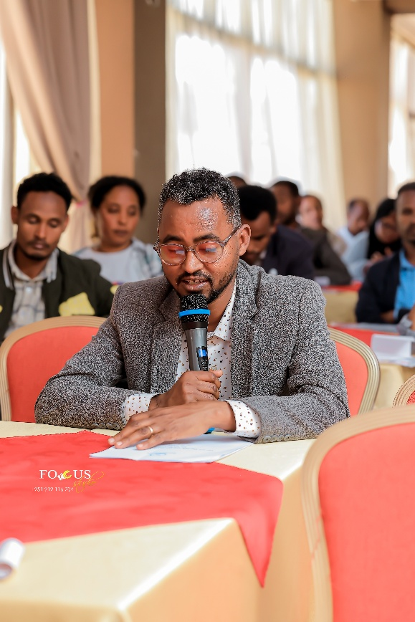
Creative awareness approaches including poetry presentations, drama performances, and student-led reflections became particularly effective in engaging participants emotionally and socially. These activities helped challenge silence and harmful social norms while making sensitive discussions more accessible and relatable for participants.
The active participation of students during awareness events demonstrated increased confidence and ownership among young people themselves. Students were not treated merely as beneficiaries, but as important actors in promoting respectful school environments and positive social change.
The community engagement activities produced several important outcomes, including:
- Increased community awareness regarding menstrual health and gender-based violence.
- Stronger collaboration among schools, parents, teachers, and local stakeholders.
- Improved openness in discussing girls’ protection and dignity issues.
- Increased volunteerism and willingness among participants to support future AMF initiatives.
- Strengthened trust and recognition of AMF as a responsive and community-driven grassroots organization.

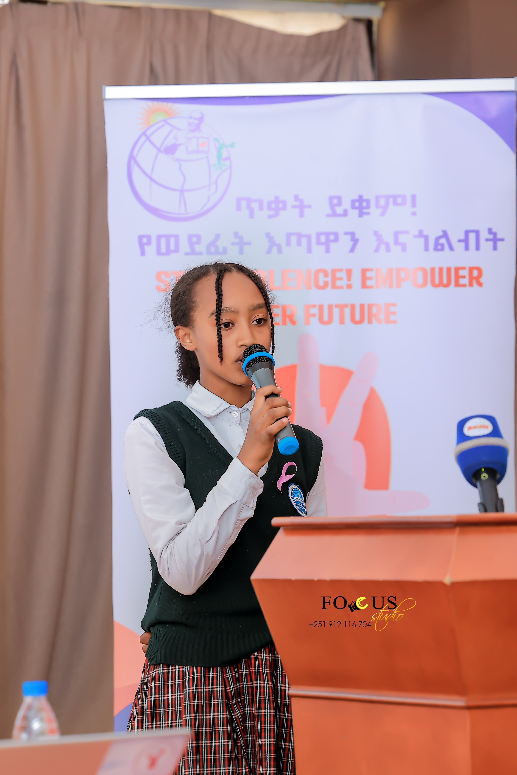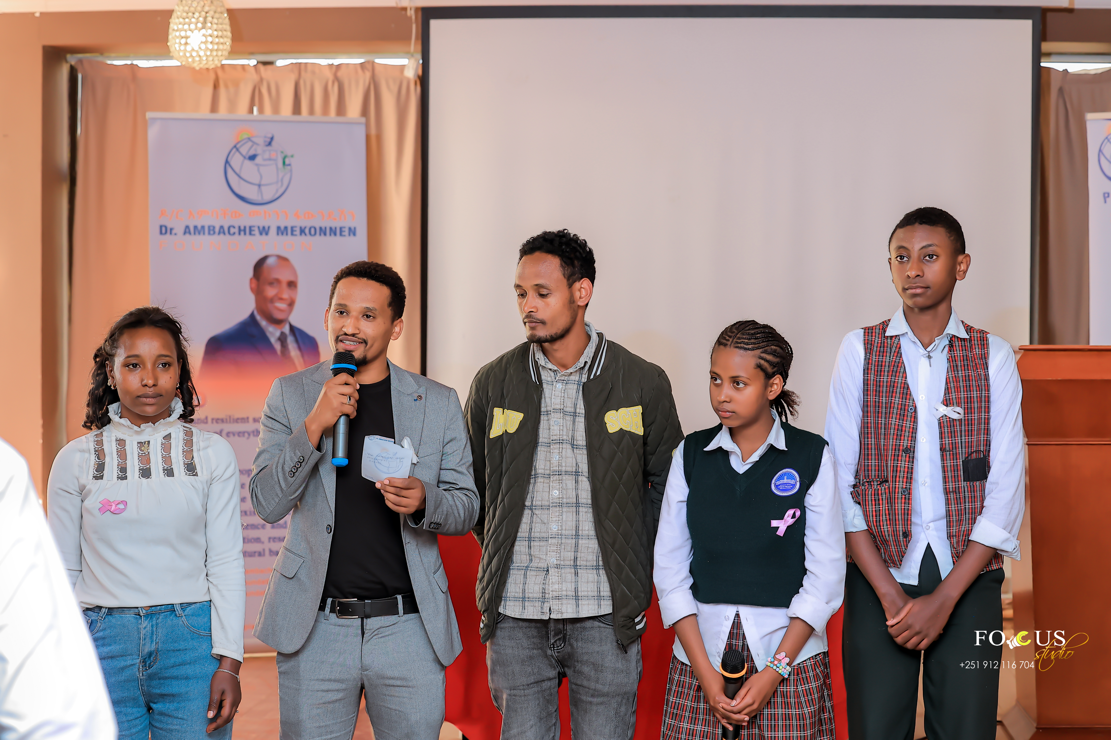
Beyond immediate project achievements, the stakeholder engagement process helped establish important groundwork for long-term systemic change in menstrual health management within schools and local education systems. Schools increasingly recognized menstrual hygiene support as an educational, protection, and gender equality issue requiring sustained institutional attention. Discussions regarding sustainability mechanisms, continued awareness creation, resource mobilization, and stronger school-based support systems were initiated during the project period and remain under further development.

Project Closure Workshop
As part of the completion of the Flow to Grow project, AMF organized a project closure and reflection workshop involving school principals, teachers, students, gender club representatives, PTAs, community stakeholders, and project supporters. The workshop served as an opportunity to review project achievements, share experiences, reflect on lessons learned, and discuss sustainability mechanisms for continued menstrual health and girls’ empowerment interventions within schools.
Participants acknowledged that the project contributed to meaningful improvements in girls’ school attendance, confidence, participation, and psychosocial well-being. School representatives reported noticeable reductions in menstruation-related absenteeism among supported students following the distribution of sanitary pads and hygiene materials. Teachers further explained that female students became more active in classroom participation, extracurricular activities, and peer interaction during the implementation period.
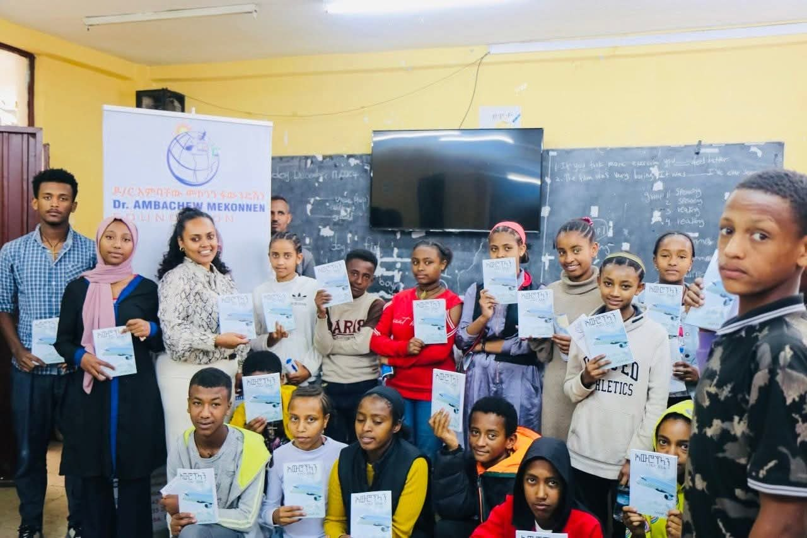
The workshop discussions also highlighted increased awareness and openness regarding menstrual health management within school communities. Participants noted that menstruation-related stigma and silence had gradually reduced as a result of awareness creation sessions conducted for both girls and boys. Male student engagement was particularly recognized as an important strategy in promoting respectful behavior, empathy, and supportive school environments.
Representatives from gender clubs and PTAs emphasized that the project strengthened collaboration between schools, parents, and communities in addressing girls’ educational and protection-related challenges. Several participants expressed appreciation for the project’s integrated approach, which combined menstrual hygiene support, awareness creation, GBV prevention, and community engagement.
Data and reflections shared during the closure workshop demonstrated that the project had expanded significantly from an initial six-month pilot intervention in five schools to an 18-month initiative reaching 15 schools across seven woredas in Addis Ketema Sub-City. Participants acknowledged that the visible impact of the intervention contributed to growing community demand and institutional support for project expansion.
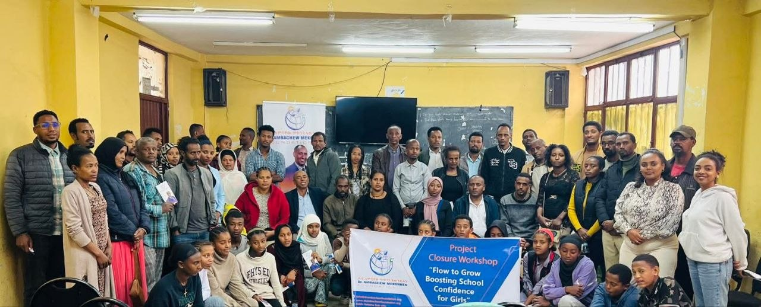
The closure workshop also served as a platform to discuss sustainability and future directions. Participants emphasized the need for continued menstrual hygiene support, stronger institutional integration within schools, resource mobilization, and strengthened coordination among education stakeholders to sustain the achievements of the project. Schools and community representatives expressed willingness to continue awareness activities and strengthen support systems for vulnerable girls beyond the project period.
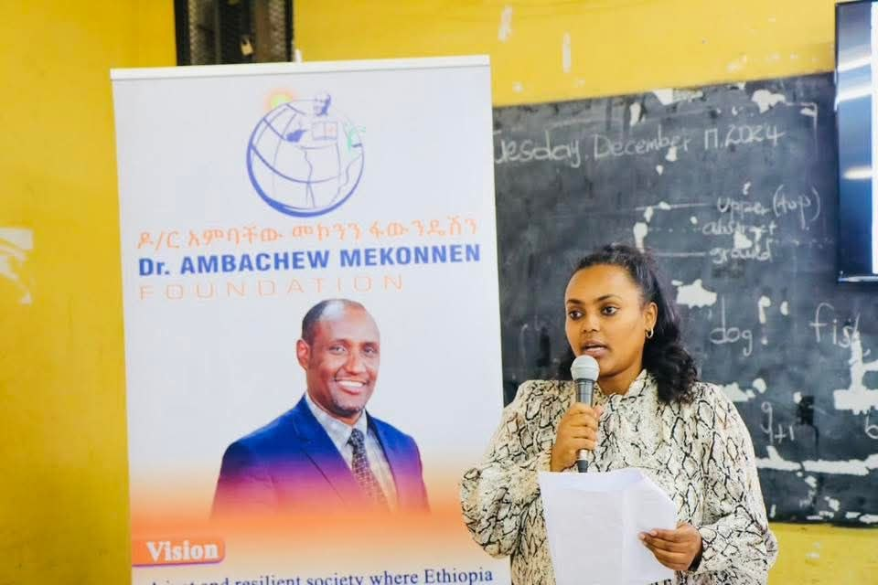
Although the Flow to Grow project demonstrated strong impact, growing community demand, and significant potential for further expansion, the intervention was unfortunately brought to a close following the recent suspension of USAID-supported development programming and operational presence in Ethiopia, which affected continuation of financial support under the USAID READ II framework. The closure therefore occurred not because the need had diminished, but at a time when schools, communities, and stakeholders were increasingly requesting continuation and expansion of the initiative. Throughout the closure workshop, school leaders, teachers, PTAs, gender clubs, students, and community representatives strongly emphasized the value and relevance of the project in improving girls’ dignity, confidence, school attendance, participation, and well-being. Participants further noted that the project had already demonstrated strong scalability, successfully growing from a six-month pilot in five schools into an 18-month intervention reaching 15 schools across seven woredas in Addis Ketema Sub-City. The experience clearly demonstrated that relatively modest investments in menstrual health and girls’ empowerment can generate meaningful educational and social outcomes when implemented through community-driven approaches. The workshop therefore highlighted an important opportunity for future donor partnership and investment to sustain, replicate, and scale the intervention to reach more vulnerable girls and underserved school communities across Ethiopia

Educational Book Donation during the Project Closure Workshop
As part of the Flow to Grow project closure workshop, educational reading books for school children were donated to participating schools and student representatives through the generous contribution of an interested individual donor and author who collaborated with AMF to support children’s learning and educational development. The donation was facilitated by AMF as part of its broader commitment to promoting children’s education, reading culture, and continuous learning opportunities beyond the formal classroom environment.
The timing of the donation was particularly meaningful, as the project closure workshop coincided with the annual school summer break period, during which students were preparing to leave schools following the completion of the academic year. Recognizing that many students have limited access to educational and recreational learning materials during school closure periods, the donor intentionally provided the books to help children spend their summer vacation in a productive, educational, and engaging manner through reading and self-learning activities at home.
During the workshop, a total of 300 educational and secular reading books were formally handed over to participating schools and students. The donation consisted of 15 packs containing 20 books each, with an estimated total value of 60,000 ETB.
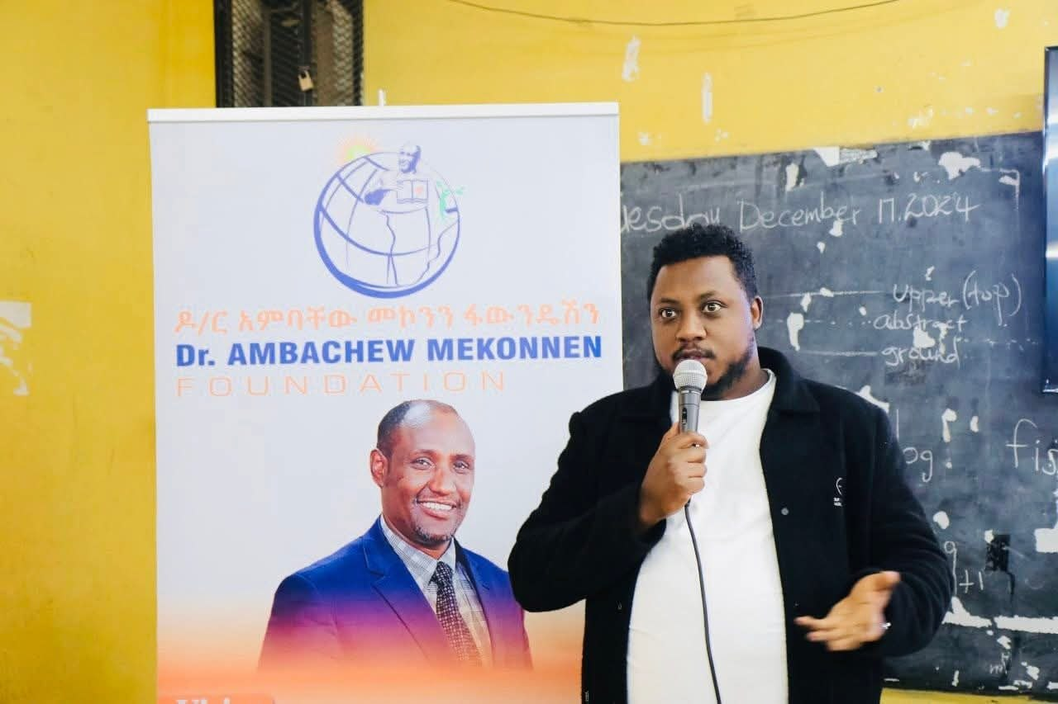
Teachers and school leaders who spoke during the closure workshop emphasized the importance of supplementary reading materials in encouraging students to maintain learning habits during the long summer vacation period. They noted that the donated books would help students utilize their leisure time constructively while also improving reading culture, creativity, curiosity, comprehension skills, and exposure to educational content beyond standard classroom textbooks.
Participants further highlighted that the donation complemented the broader objectives of the Flow to Grow project by contributing to students’ confidence, educational participation, personal development, and overall well-being. The activity also demonstrated the importance of community solidarity and individual contribution in supporting vulnerable children and strengthening educational opportunities within local school communities.

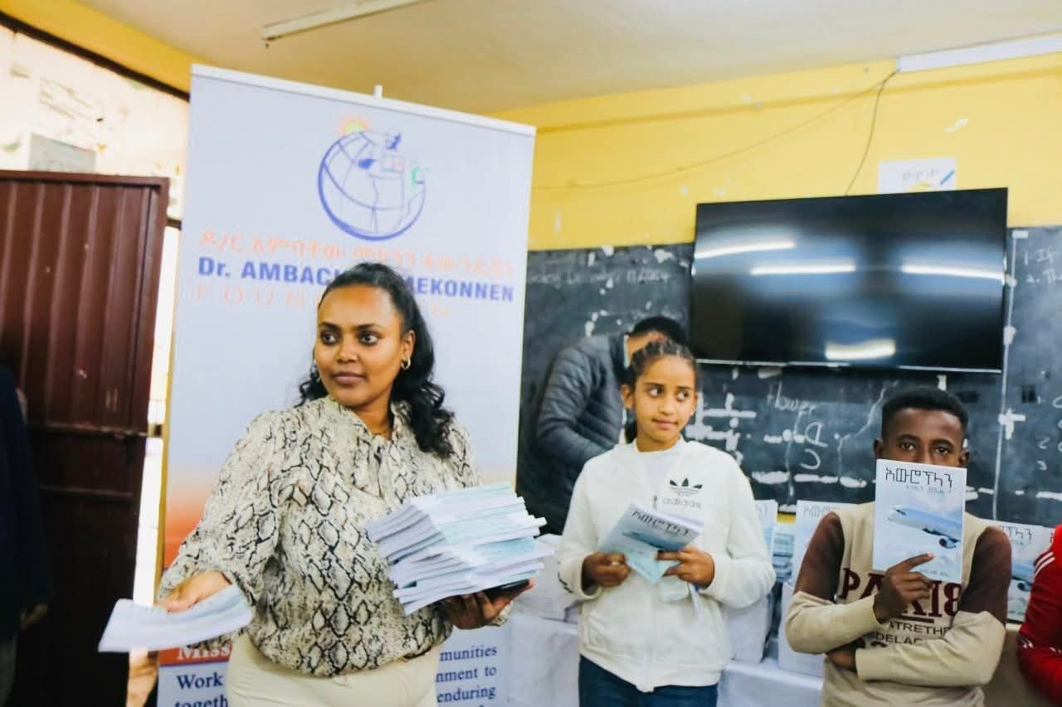
The contribution strengthened collaboration between AMF, schools, teachers, community stakeholders, and individual supporters while encouraging continued partnership and investment in educational enrichment initiatives targeting children and adolescents.

Endline Assessment Findings

6.1 School Principals’ Perspectives
The endline assessment conducted with 14 school principals revealed strong institutional recognition of menstrual health and hygiene management as a critical issue affecting girls’ educational participation, confidence, psychosocial well-being, and overall school performance. The findings demonstrated that school leaders increasingly understand the direct relationship between menstrual health challenges and girls’ ability to fully participate in education.
The assessment showed that menstruation-related absenteeism remained one of the most widely recognized concerns among school principals. Approximately 11 out of the 14 respondents identified regular school absence during menstruation as a significant challenge affecting female students. Principals explained that many girls previously missed classes due to lack of sanitary materials, fear of leakage or embarrassment, physical discomfort, and limited confidence in managing menstruation safely within school environments.
In addition to absenteeism, several principals highlighted that menstrual health challenges negatively affected girls’ classroom confidence, concentration, participation, and interaction with peers and teachers. Some respondents explained that girls often became less active in class discussions or isolated themselves socially during menstruation due to fear of stigma and teasing.  Importantly, all 14 respondents (100%) confirmed that menstrual health and hygiene challenges directly affect girls’ school attendance and educational participation. Similarly, all respondents agreed that poor menstrual hygiene management contributes to increased risks of absenteeism, disengagement from learning, and potential school dropout among female students. | 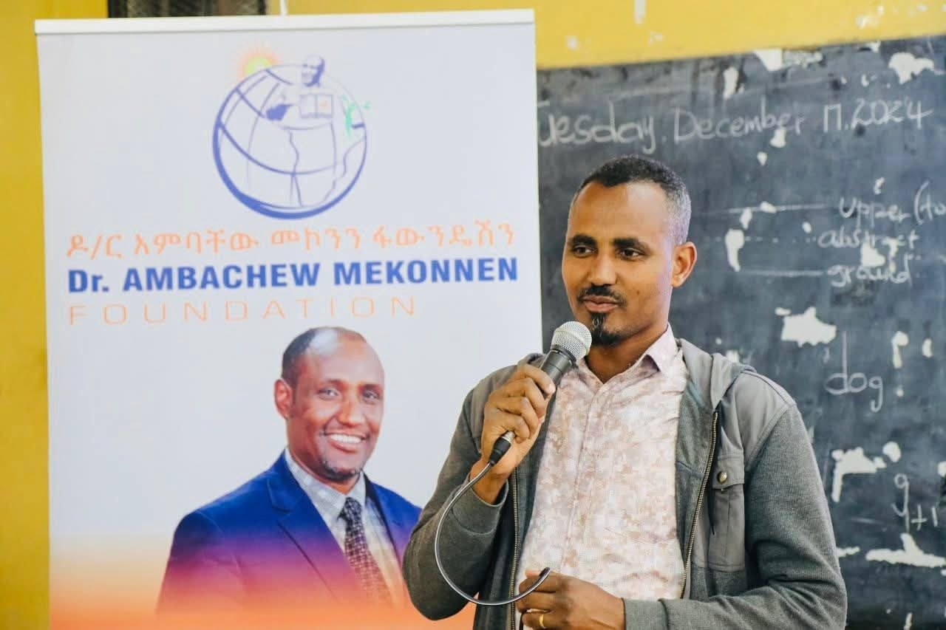
The findings further revealed important improvements in institutional awareness and school-level engagement compared to the baseline assessment conducted before project implementation. Approximately 9 principals reported that schools had strengthened menstrual health support mechanisms and awareness activities during the project period. Schools increasingly recognized menstrual health management as part of their broader responsibility toward promoting safe, inclusive, and supportive learning environments.
Several principals also acknowledged improvements in openness and communication among students regarding menstrual health issues. According to respondents, girls became more willing to seek support, discuss challenges, and participate in awareness activities following the project interventions. Schools also observed greater engagement of teachers and gender clubs in supporting female students and promoting awareness creation activities.
The assessment further indicated growing institutional commitment toward sustaining menstrual health-related activities beyond the project period. Many principals expressed willingness to continue awareness creation efforts, strengthen school support systems, and collaborate with stakeholders to mobilize additional resources for girls’ menstrual hygiene needs.
At the same time, respondents emphasized that significant challenges still remain. Financial limitations, inadequate access to sanitary materials, cultural stigma, and limited institutional resources were repeatedly identified as barriers affecting sustainability and broader scale implementation. Nevertheless, the findings clearly demonstrated that the project contributed to meaningful improvements in institutional awareness, stakeholder engagement, and recognition of menstrual health as a critical educational and protection issue.

6.2 School Girls’ Perspectives
The endline assessment conducted with 10 female students provided important insights into the impact of the Flow to Grow project on girls’ educational participation, confidence, menstrual health management, and psychosocial well-being. The responses demonstrated that the intervention contributed to noticeable improvements in school attendance, awareness, confidence, and openness in discussing menstrual health-related issues.
The assessment findings revealed that 8 out of 10 respondents reported experiencing challenges in attending school comfortably during menstruation before the project intervention. The major challenges identified included lack of sanitary materials, fear of leakage, embarrassment, teasing from peers, and discomfort in managing menstruation within school environments.
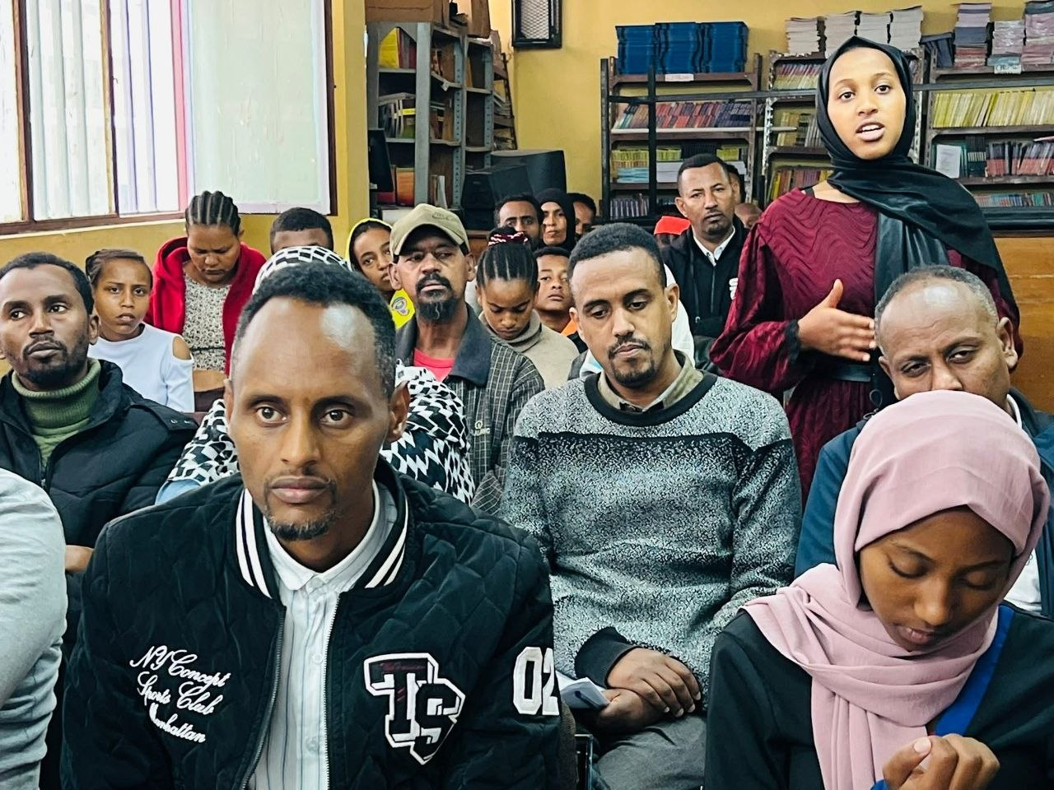
Regarding school attendance, 7 out of 10 respondents confirmed that they had previously missed classes during menstruation due to menstrual health-related difficulties. However, following the intervention, most respondents indicated improvements in their ability to attend school more consistently after receiving sanitary pads and hygiene support materials.
The assessment further showed that 9 out of 10 respondents believed that the provision of sanitary pads and hygiene materials positively improved their confidence and sense of dignity while attending school. Students explained that the support reduced stress, fear, and discomfort associated with menstruation management.
In relation to classroom participation, 8 respondents stated that they became more confident participating in classroom discussions and school activities following the intervention. Several girls explained that before the project they often remained silent or avoided participation during menstruation due to embarrassment and low self-confidence.
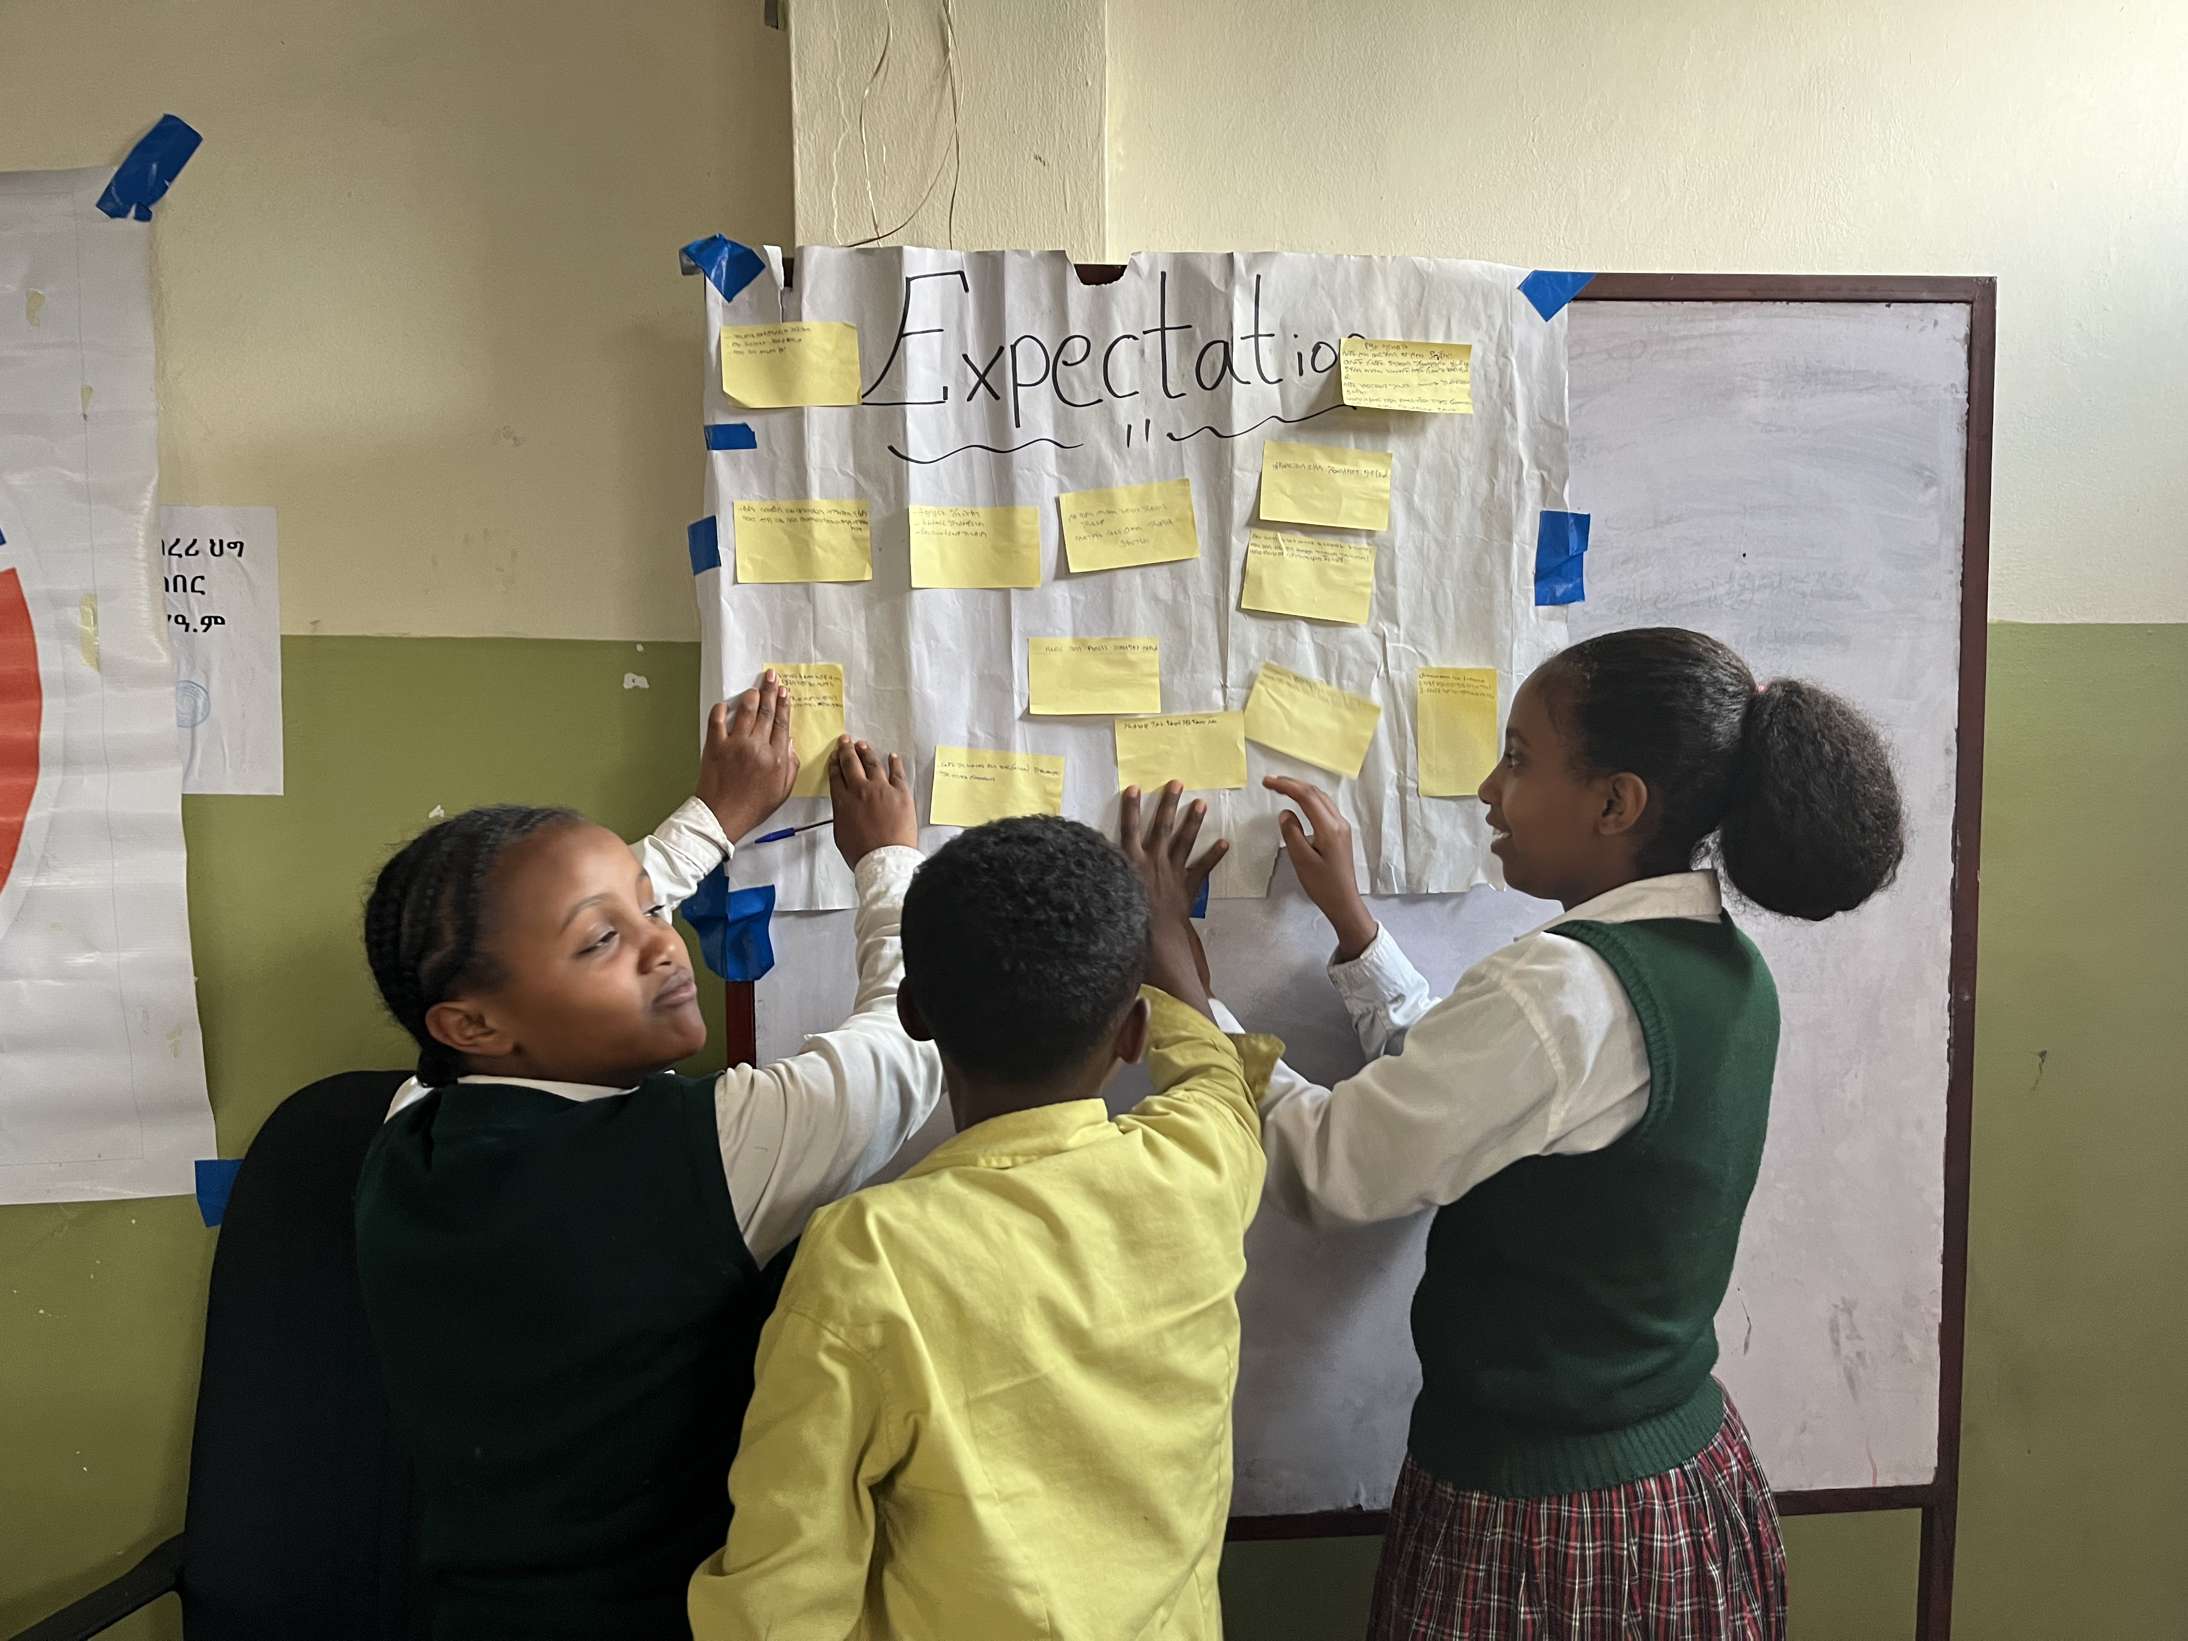

The awareness creation component of the project also demonstrated strong positive outcomes. All 10 respondents confirmed that the training sessions improved their understanding of menstrual health and hygiene management. Students reported gaining better knowledge about personal hygiene, menstrual management practices, and the importance of seeking support when needed.
The findings additionally indicated improvements in communication and openness regarding menstrual health issues within schools. Approximately 8 out of 10 respondents reported feeling more comfortable discussing menstruation-related concerns with teachers, peers, or gender club members compared to before the project.
The inclusion of boys in awareness sessions also appeared to contribute to positive behavioral changes within schools. Seven respondents observed improvements in the attitudes and behavior of male students, including reduced teasing and increased respect toward girls during menstruation.
Regarding school support systems, 9 respondents acknowledged that teachers, gender clubs, and school leaders became more supportive and responsive toward girls’ menstrual health concerns during the project period. Students noted that school staff became more approachable and willing to provide emotional and practical support when needed.
Despite the positive changes observed, 6 out of 10 respondents indicated that access to menstrual hygiene materials remains a continuing challenge for many girls outside the project support period. Respondents emphasized the importance of sustaining and expanding similar interventions to reach more vulnerable students.
Overall, the assessment findings demonstrated that the Flow to Grow project contributed to significant improvements in girls’ confidence, school attendance, awareness, participation, and psychosocial well-being while helping reduce stigma and silence surrounding menstruation within school communities.

Annexes
- Sample filled out questionnaire
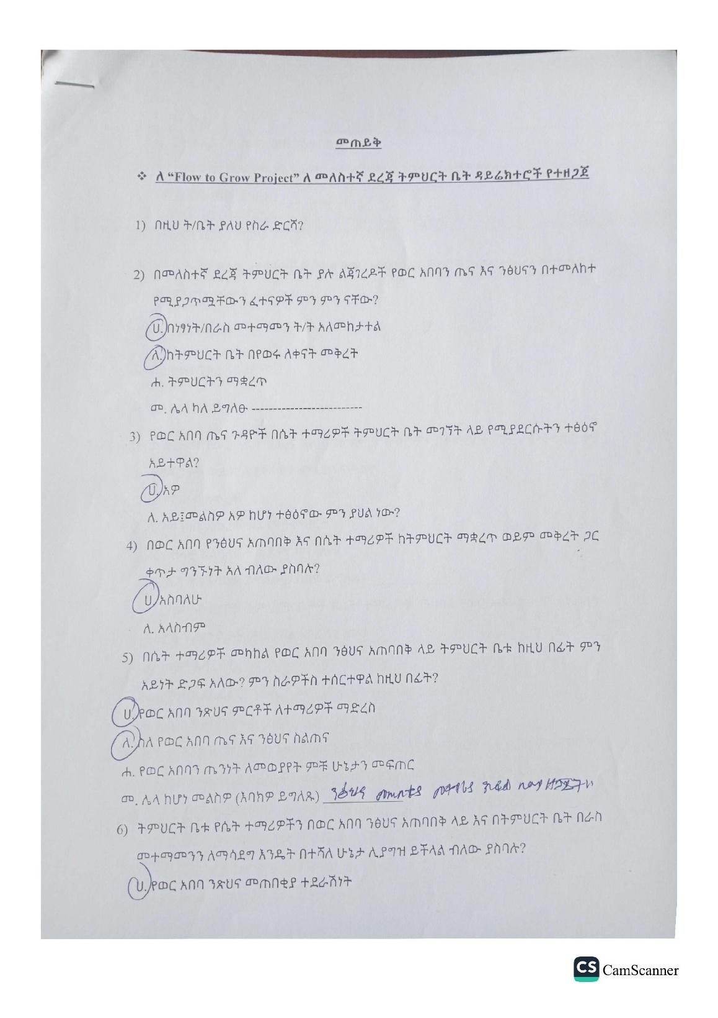

- Workshop presentation PowerPoint layout
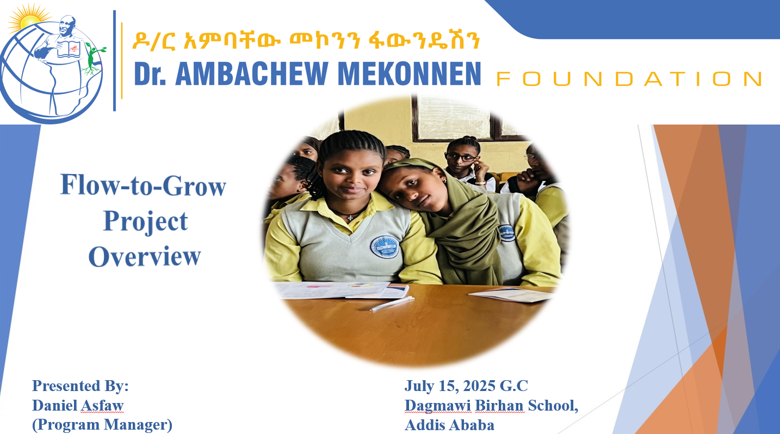

- Sample event schedules format
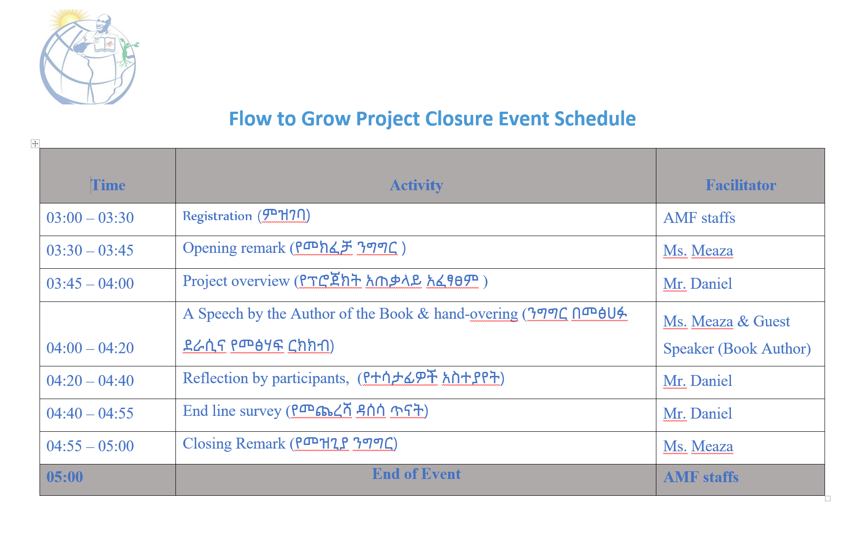
- A School girl presenting a poem at the project workshop event
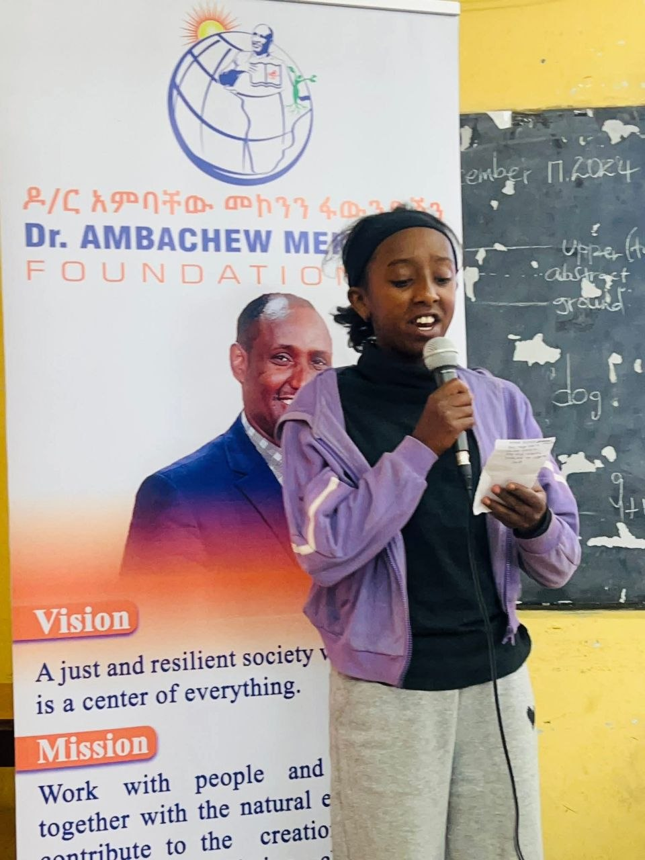

- School girls performance in artistic activities in school gender clubs
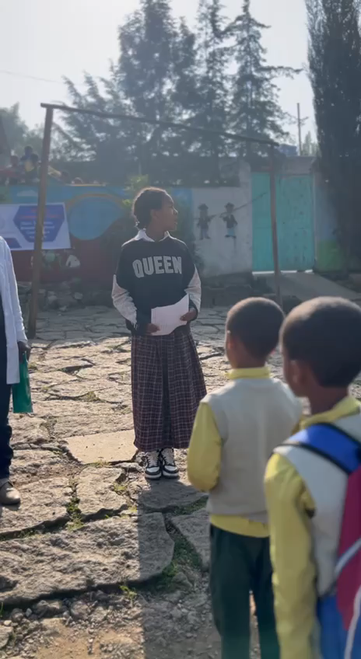

- Material dispatch note
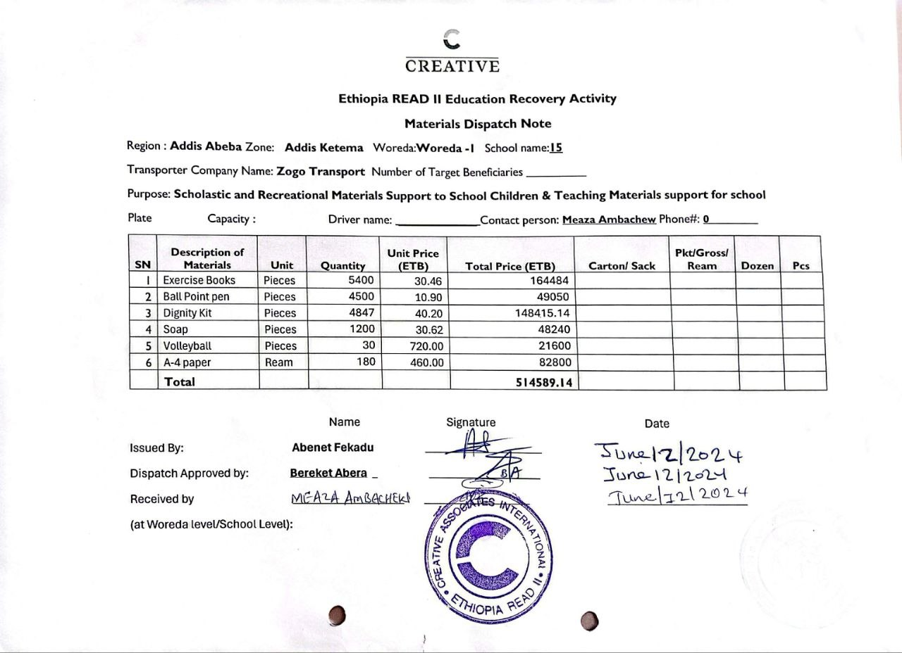
- Presentation by AMF program manager during an event
